COMPUTATIONAL LAB

FOR

ENERGY ENGINEERING

ME6491E



SANKAR MAITY
M251015ME
M.TECH IST YEAR IN ENERGY ENGINEERING
DEPARTMENT OF MECHANICAL ENGINEERING
NATIONAL INSTITUTE OF TECHNOLOGY
CALICUT

VELOCITY BOUNDARY LAYER FLOW OVER A FLAT PLATE

OBJECTIVE:
To study the velocity boundary layer flow over a flat plate and investigate the velocity profile across the boundary layer using Ansys Workbench.
PROBLEM STATEMENT:
Consider a flat plate of length 10 m and breadth 5 m, exposed to an oncoming fluid flow at velocity 0.5 m/s. The fluid properties such as density and viscosity are known. The study aims to simulate the velocity distribution and boundary layer characteristics along the surface of the flat plate. This simulation provides insights into the boundary layer thickness, velocity profile, and other relevant flow parameters.
PHYSICAL DOMAIN:
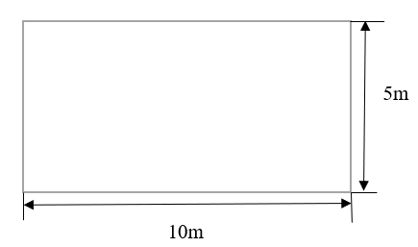
Figure 1: Flat plate
COMPUTATIONAL DOMAIN:
- Create a 2D geometry using Design modeler
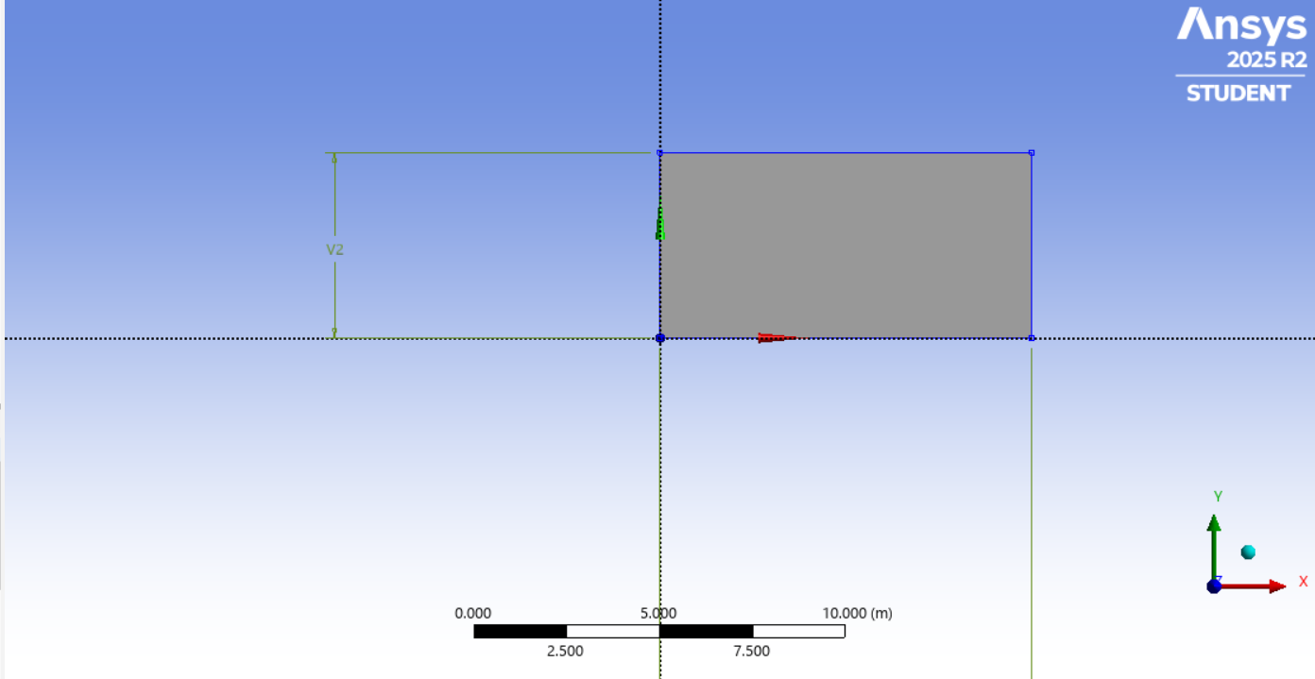
Figure 2: 2D Geometry
MESHING:
- Fluid flow fluent > Meshing
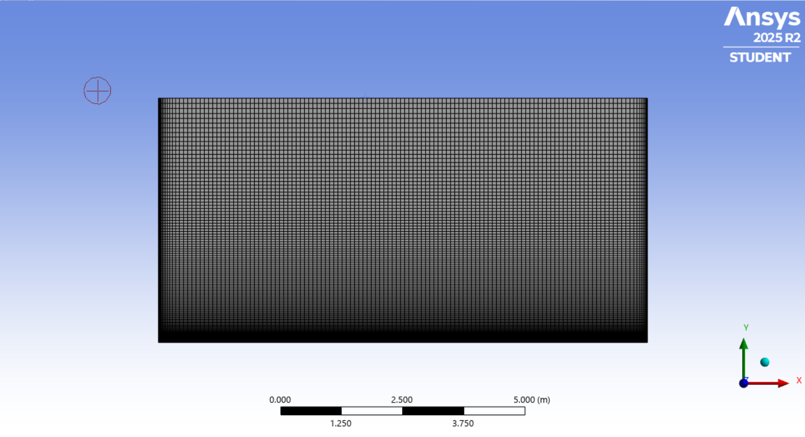

Figure 3: Meshing
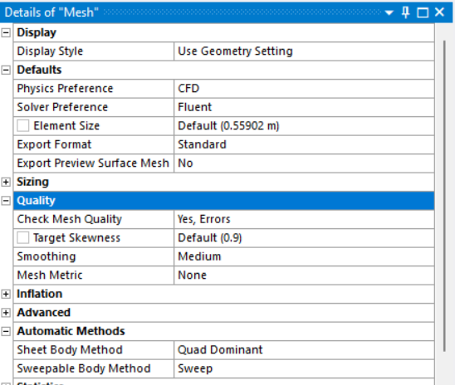
Figure 4: Details of Mesh
SETUP:
- Double click the setup.
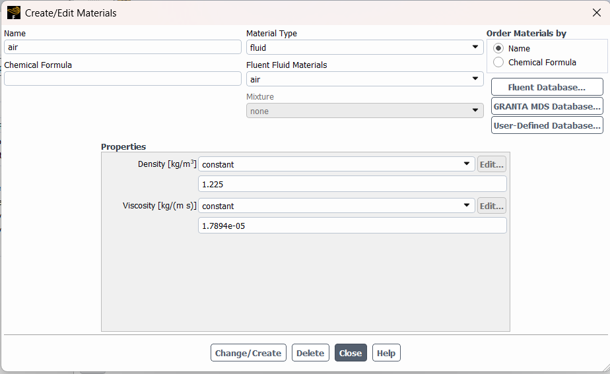
Figure 5: Material details
Based on the calculation of Reynolds number, Re_{L} = (ρU∞L)/ μ = (1.225*0.5*10)/(1.7894*10⁻⁵) = 3.42*10⁵ < 5*10⁵
- Here the flow is laminar.
RESULTS:
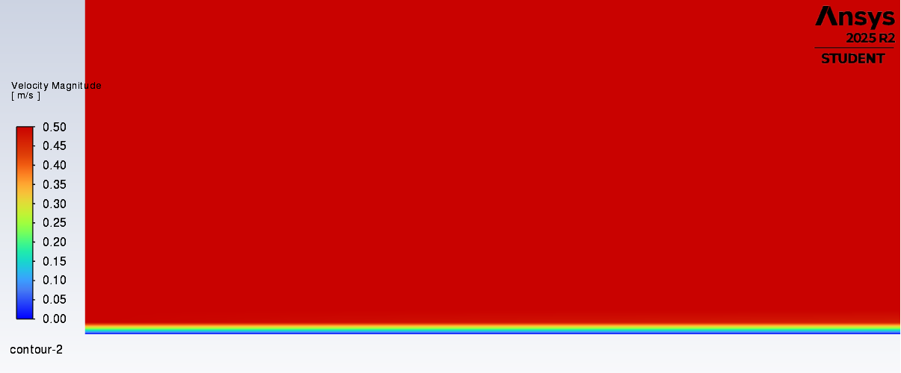
Figure 6: Velocity Contour
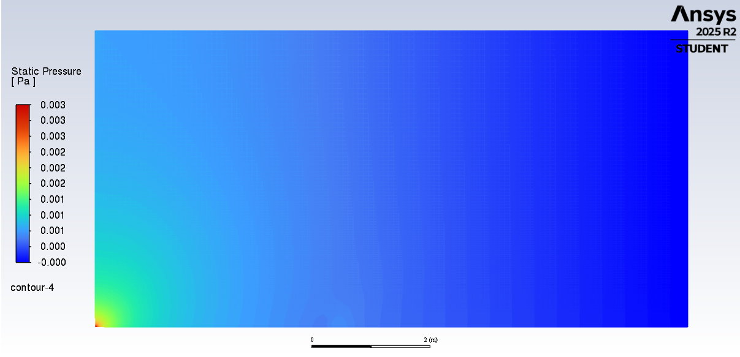
Figure 7: Pressure Contour
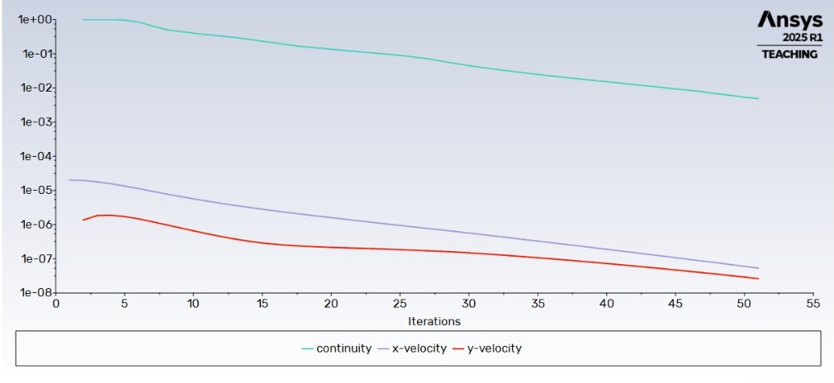
Figure 8: Scaled Residuals

